Run Jenkins Build From Command Line

Run Jenkins build from command is very simple in Linux system. Jenkins has support to command line client that allows you to access Jenkins from command line.

To Trigger Jenkins build from command line some prequiste are there

Jenkins service is running.
Enable security option under “Configure Global Security”
Go to jenkins dashboard in Home page ( e.g http://localhost:8080/ ) -> Manage Jenkins
-> Configure Global Security -> Click on “Enable security” checkbox

You can also configure “Access Control” and “Authorization” option in Global Security page.
Jenkins allow us to trigger Jenkins build with any specific user, For that we have to pass username and password in command line.

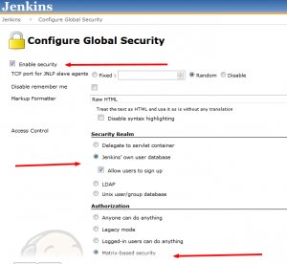

You can check all CLI option in http://<jenkins server >/cli/ ( e.g http://localhost:8080/cli/ ) page.

To access CLI feature in Jenkins download jenkins-cli.jar (http://<jenkins server>/jnlpJars/jenkins-cli.jar) and place this jar your directory or location from you are going to run jenkins build command.

Jenkins Command build Option:-

>set JENKINS_URL=http://localhost:8080/jenkins
>java -jar <path to Jenkins_cli.jar> --version
or
>java -jar <path to Jenkins_cli.jar> -s http://localhost:8080/jenkins –version

build in help for Cli commands: http://localhost:8080/jenkins/cli/

